
Year 10
Pathway 2

Mini Test 3
Volume

Score: /25
Name: ______________________ Total Time: 30 minutes

Full working out must be shown to get full marks.
Attempt all questions

Resources allowed:
1 A4 page, (1 side) of hand written notes
Calculator

Multiple Choice
Circle one answer

Question 1 (1 Marks)
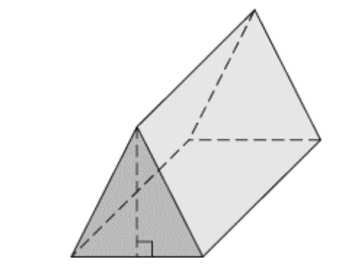
Identify the following 3-D object.

- cylinder
- right triangular prism
- rectangular pyramid
- right rectangular prism

Question 2 (1 Marks)
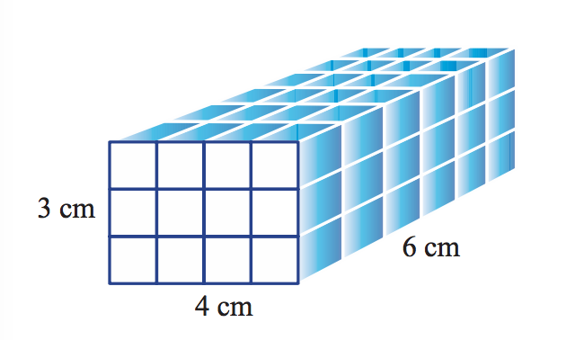
The volume of the shape shown is:

- 13 cm3
- 27 cm3
- 72 cm2
- 72 cm3

Question 3 (1 Marks)
The volume of a cube of side length 3 cm is:
- 9 cm3
- 27 cm3
- 54 cm3
- 27 cm2

Question 4 (1 Marks) Which set of dimensions belongs to a right rectangular prism with a volume of 440 cm³?
- 6 cm, 12 cm, 5 cm
- 8 cm, 5 cm, 11 cm
- 7 cm, 9 cm, 6 cm
- 12 cm, 2 cm, 5 cm

Question 5 (1 Marks)
A soup can has a radius of 4.3 cm and a height of 11.6 cm. What is the volume of the soup can to the nearest tenth of a cubic centimetre?

- 49.9 cm3
- 168.4 cm3
- 673.5 cm3
- 1816.8 cm3

Short Answer
Please show all working

Question 6 (4 Marks)

Calculate the volume of the Triangular prism showing all working
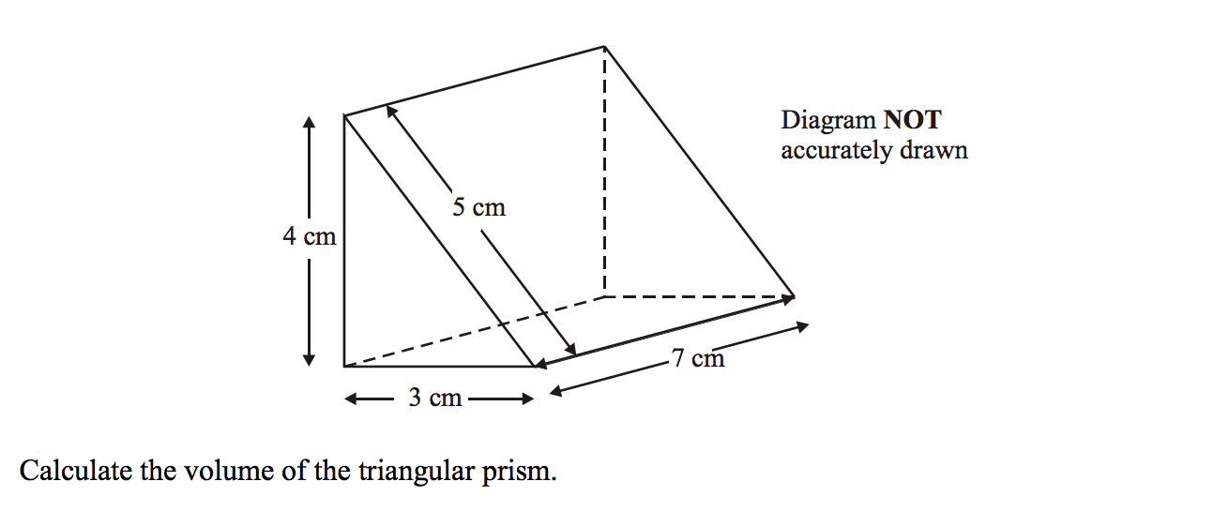

Question 7 (2,3 - 5 Marks)

A cylinder has a radius of 5 cm.

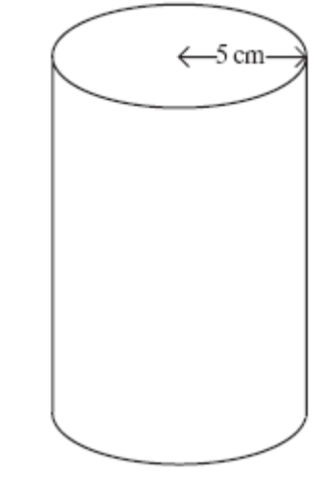
- Calculate the area of a circular end of the cylinder.

(b) The cylinder has a volume of 250 cm³ . Calculate the height of the cylinder.

Question 8 (5 Marks)
Calculate the volume of the prism showing all working
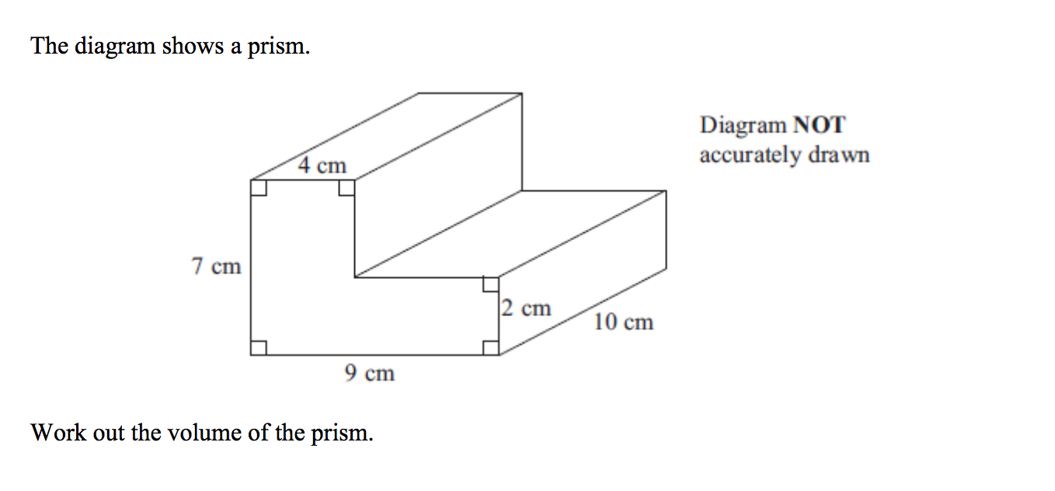

Question 9 (6 Marks)
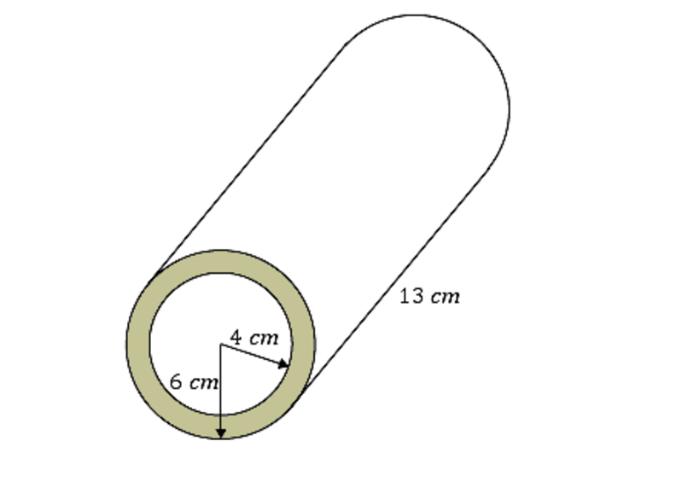
A 13 cm concrete cylindrical pipe has an outer radius of 6 cm and an inner radius of 4 cm as shown.. Find the volume of concrete required to make the pipe, correct to 2 decimal places.

End of Test

